I did not use any help provided from the instructing team and tried to implement everything from the scratch. Therefore, pretty much everything is different from what is provided by the instructing team. To begin with, I used an OOP in reading and manipulating the data.

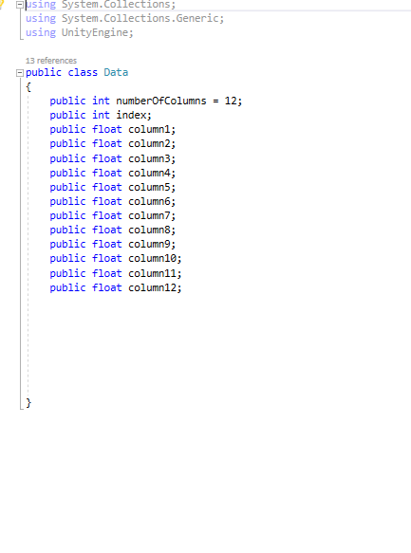

I also used different functions for normalizing (I normalized the data between -1 and +1) and pretty much every other function that I used was different. As I mentioned in my debugging, the only problem that I faced was adding selection as an interaction to the project. I had to learn about the raycasting, which was a little challenging for me. But fortunately, I was able to solve that issue myself.